IMAGE RECOGNITION

# Phase 2

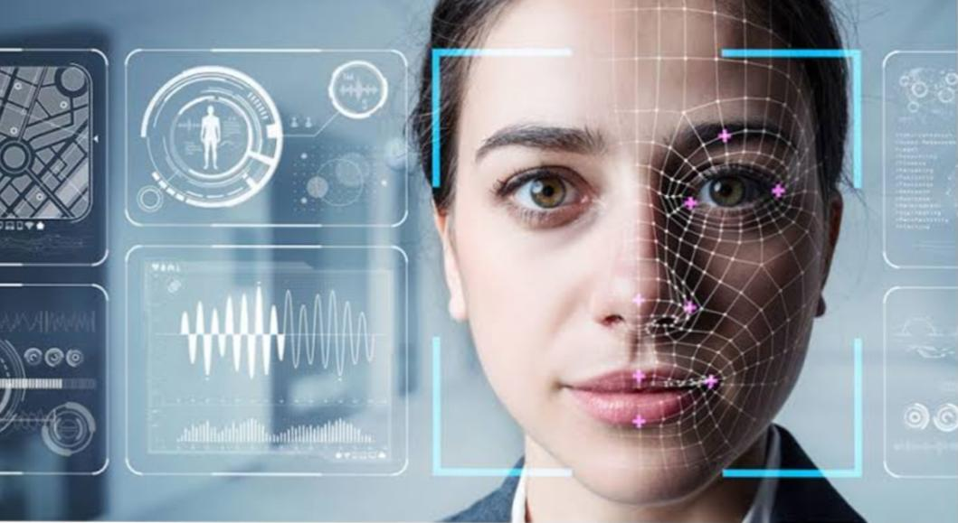

# Abstract :

Image recognition, in the context of machine vision, is the ability of software to identify objects, places, people, writing and actions in digital images. Computers can use machine vision technologies in combination with a camera and artificial intelligence (AI) software to achieve image recognition.

**Problem definition :**

The process of identifying and detecting an object or a feature in a digital image or video, machine or computer vision encompasses the methods that enable a machine to capture, process and interpret images to intelligently undertake a given task.

**How does Image recognition work?**

Typically the task of image recognition involves the creation of a neural network that processes the individual pixels of an image. These networks are fed with as many pre-labelled images as we can, in order to “teach” them how to recognize similar images**.**

So let me break the process for you in some simple steps:

1. We need a dataset containing images with their respective labels. For example, an image of a dog must be labelled as a dog or something that we can understand.
2. Next, these images are to be fed into a Neural Network and then trained on them. Usually, for the tasks concerned with images, we use convolutional neural network. These networks consist of convolutional layers and pooling layers in addition to Multiperceptron layers(MLP). The working of convolutional and pooling layers are explained in the below.

1. We feed in the image that is not in the training set and get predictions.

In the coming sections, by following these simple steps we will make a classifier that can recognise RGB images of 10 different kinds of animals.

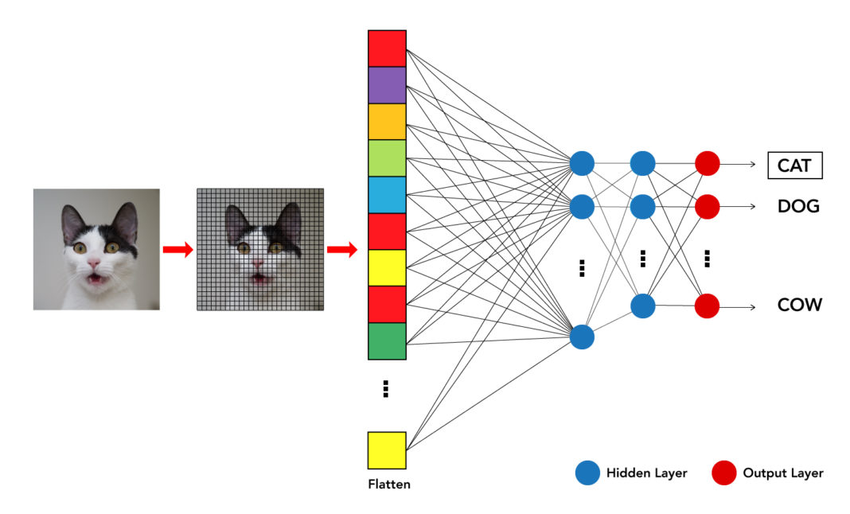

**The Process of ImagE Recognition Systems:**

* **Dataset with training data The image recognition models require training data (video, picture, photo, etc.). Neural networks need those training images from an acquired dataset to create perceptions of how certain classes look. For example, an image recognition model that detects different poses (pose estimation model) would need multiple instances of different human poses to understand what makes poses unique from each other.**
* **Training of Neural Networks for Image Recognition The images from the created dataset are fed into a neural network algorithm. This is the deep or machine learning aspect of creating an image recognition model. The training of an image recognition algorithm makes it possible for convolutional neural networks image recognition to identify specific classes. There are multiple well-tested frameworks that are widely used for these purposes today.**
* **AI Model Testing The trained model needs to be tested with images that are not part of the training dataset. This is used to determine the usability, performance, and accuracy of the model. Therefore, about 80-90% of the complete image dataset is used for model training, while the remaining data is reserved for model testing.**

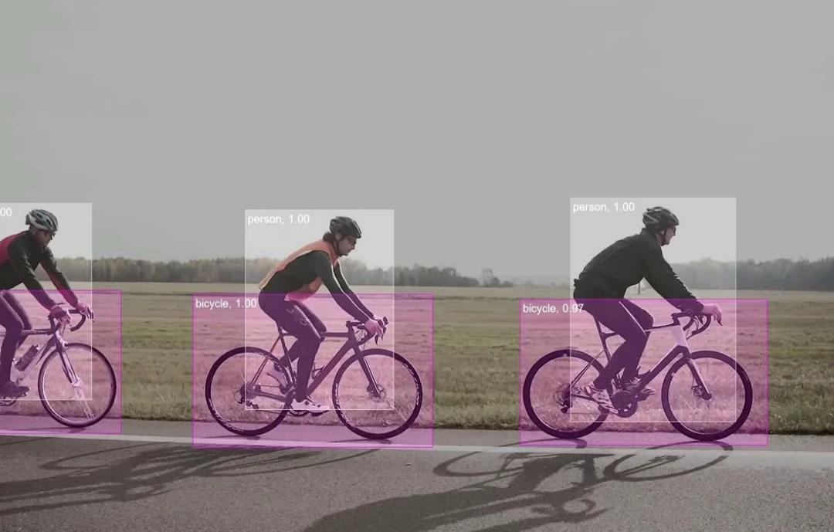

**Conclusion :**

Using image recognition, a computer vision system can recognize patterns and regularities in all that numerical data that correspond to things like people, or vehicles, or tumors. It essentially automates the innate human ability to look at an image, identify objects within it and respond accordingly.